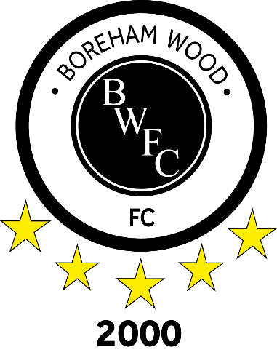

Borehamwood 2000 Football Club
Disciplinary Policy

- Introduction
  - Borehamwood 2000 Football Club (“the Club”) promotes sportsmanship and fair play in all our teams towards our own players, officials and supporters, to the match officials and to our opponents.
  - It is also important the Club provides a high standard of hospitality to players, officials and spectators before, during and after the game.
  - The Club expects high standards from its players, officials, members and supporters and therefore operates a fair but strict discipline procedure at all its events and matches.
  - As a matter of procedure, the club does not impose financial fines on its players, officials and supporters, but will enforce FA/Herts FA rulings & fines and expects these will be paid by the offending parties.
  - For children under the age of 18 all disciplinary correspondence and interaction must be via their registered parent or guardian, to include FA/Herts FA rulings and appeal representation.
  - All disciplinary events are reported to the Club’s Welfare Officer as a matter of course.

- General Misconduct
  - The club expects high standards from its players, officials, members and supporters; therefore, it is the responsibility of each Team Manager to report any misconduct events to the Club Secretary within twenty-four hours of the incident.
  - Upon receipt of the report a review will be undertaken by the Disciplinary Committee.
  - Penalties will be imposed if deemed appropriate.

- Disciplinary Committee
  - The Disciplinary Committee consisting of the following Club Officers:
    - Club Chairperson, Club Secretary & Club Welfare Officer.

